IIS Deploy Steps

Create a deployable package from Visual Studio

1. Right click on Agnie.Test and click on publish
2. Select Web Server (IIS)

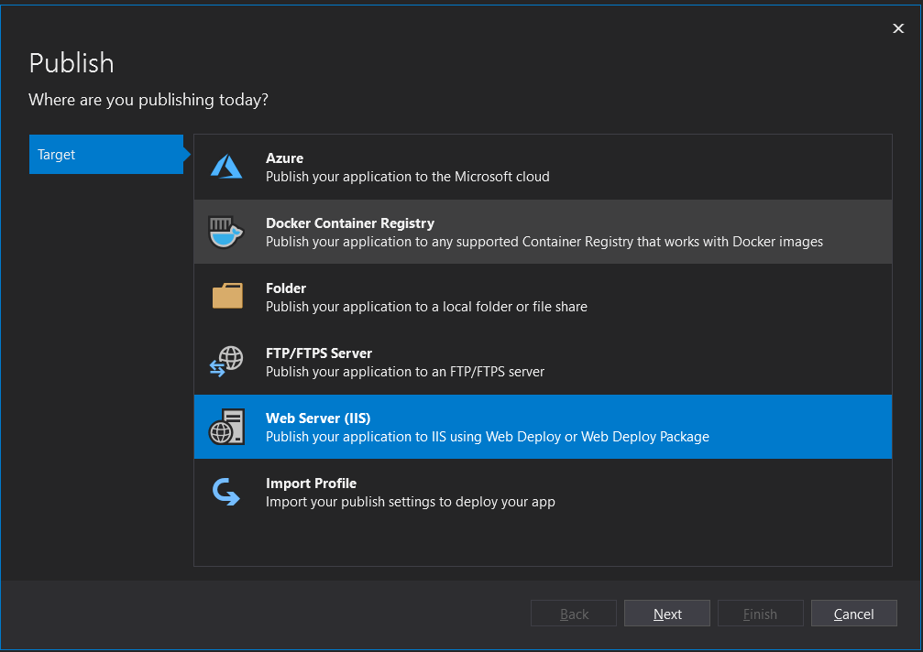

1. Select Web Deploy Package

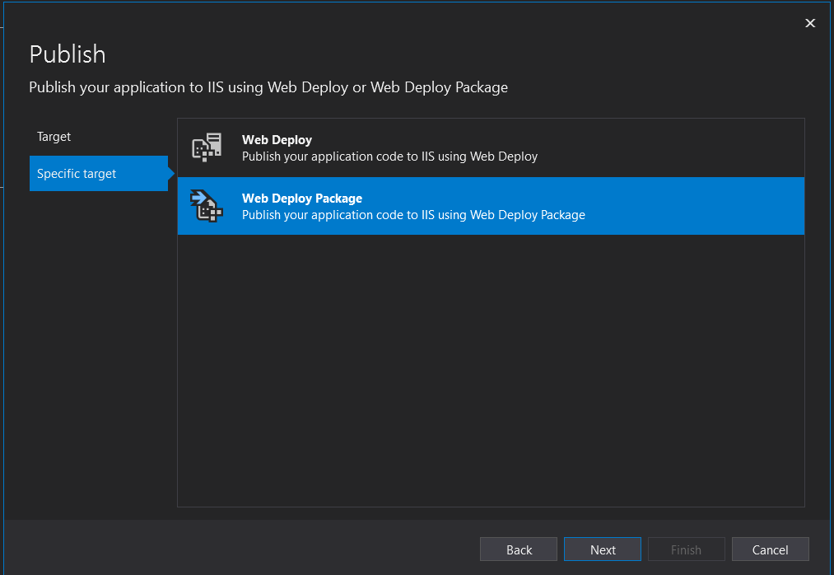

1. Provide Package Location and Site Name

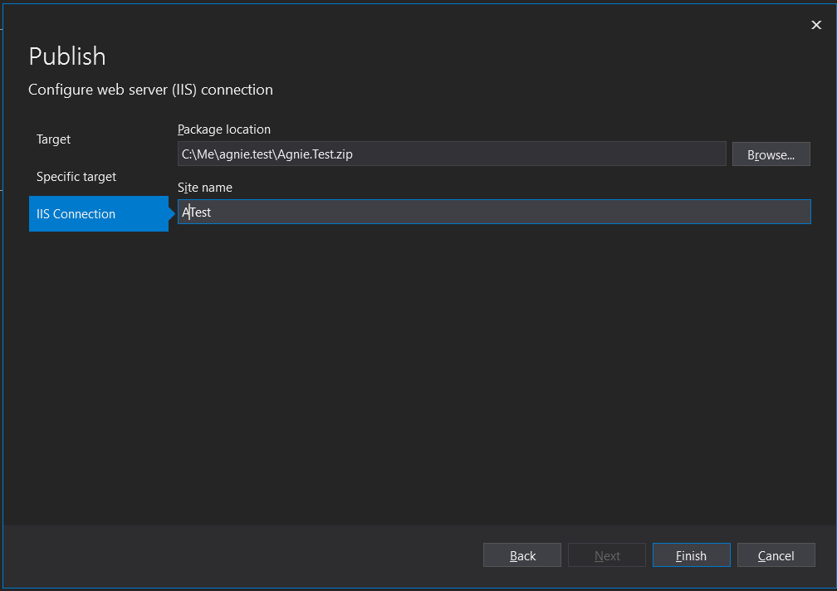

1. Click on Edit
2. Select Publish Method as File System and enter location
3. 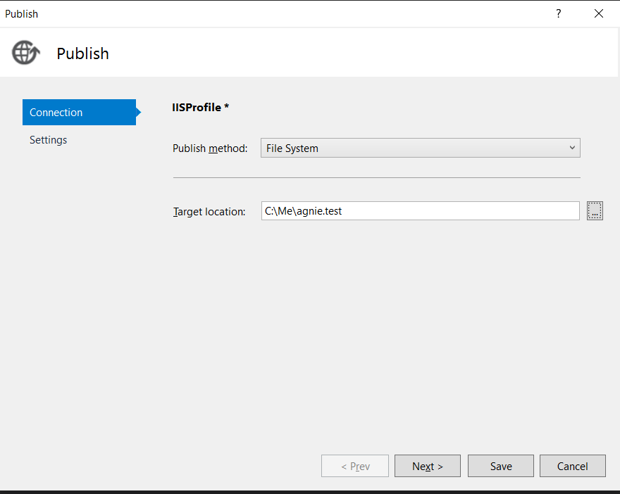
4. Click Next and select below options
5. 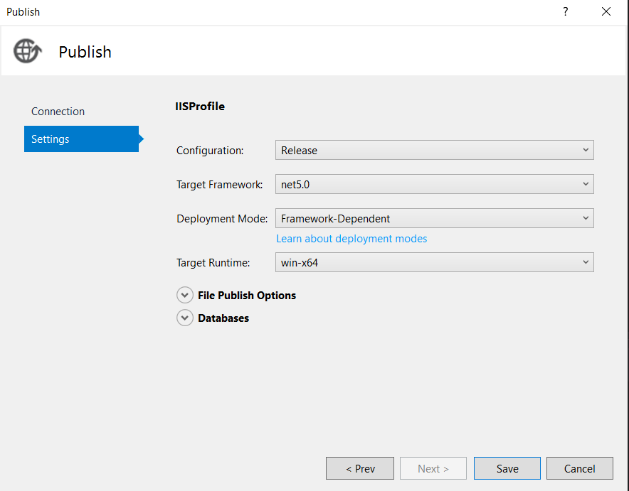
6. Click Save
7. Click Publish

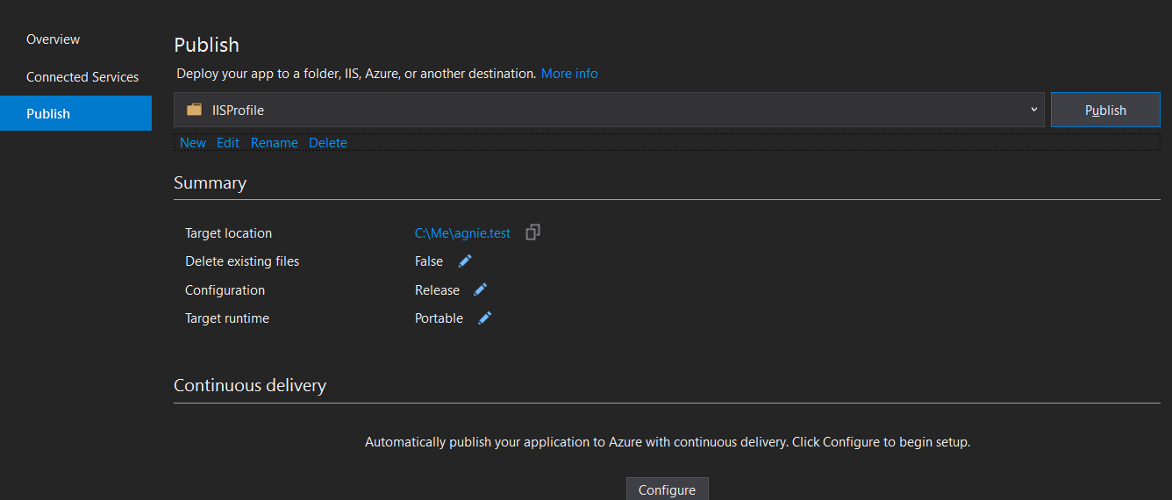

1. (optional if not already done)Install <https://dotnet.microsoft.com/download/dotnet/thank-you/runtime-aspnetcore-5.0.3-windows-hosting-bundle-installer>
2. Use the published package to host website.

Troubleshoot steps

1. Make sure the application pool is configured as below

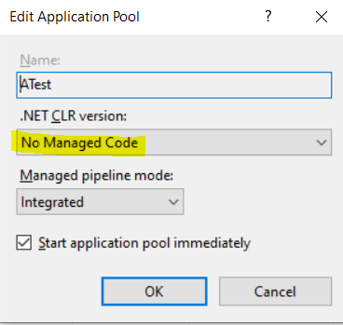

1. When publishing the package make sure right Target runtime is selected as per server setting

